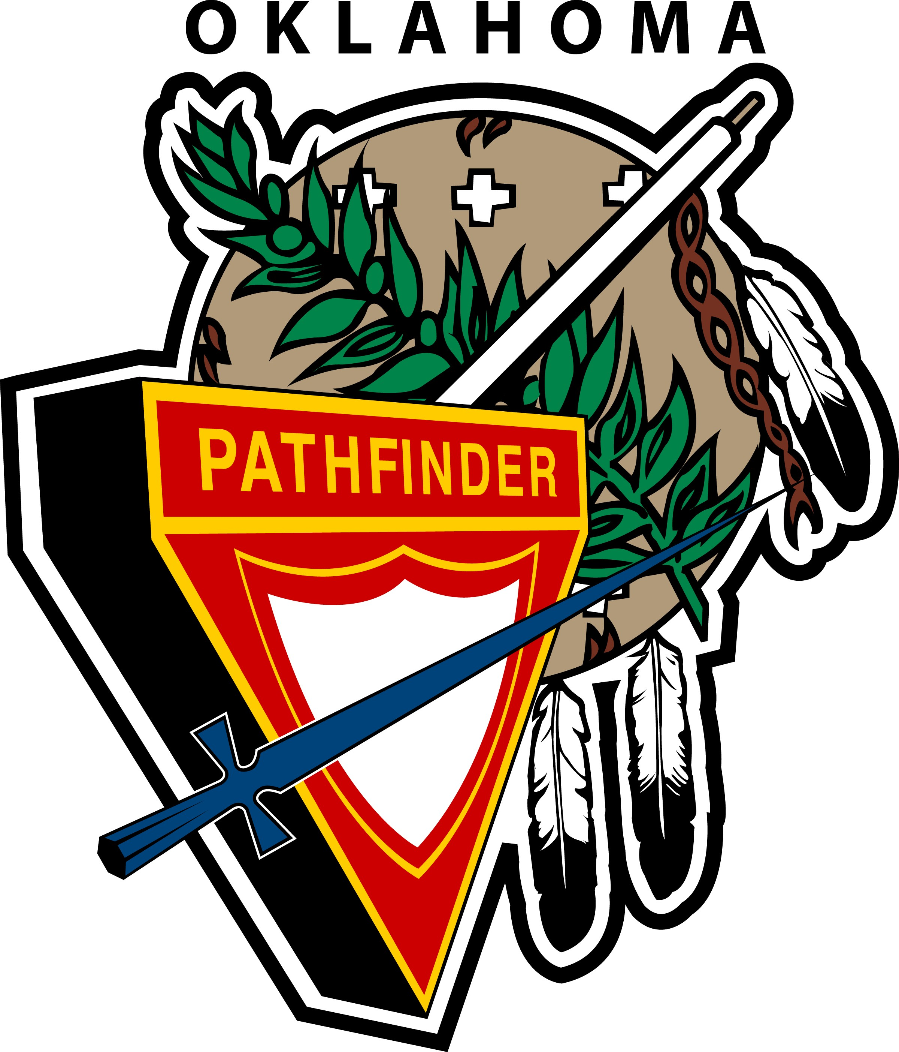

Pathfinder

Glenda Sweezey, Area 1:
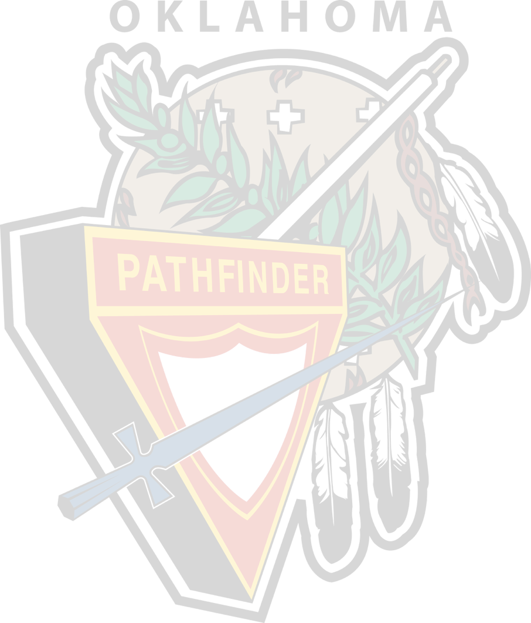
Bartlesville, Nowata, Vinita, Miami, Ketchum, Jay, , Owasso, Collinsville, Pryor, Wagner, Tahlequah, Stilwell, Tulsa area churches

Steve Szalay, Area 2:
Ponca City, Cleveland, Stillwater, Perkins, Sand Springs, Chandler, Bristow, Sapulpa, Seminole, Okmulgee, Muskogee, Stigler, Sallisaw, West Siloam Springs.

Don Adams, Area 3:
Guthrie, Norman, Greater Oklahoma City area churches.

Chuck and Donna Hill, Area 4:
Altus, Lawton, Chickasha, Duncan, Pauls Valley, Ada, Davis, Sulphur, Shawnee, Ardmore, Coalgate, Durant, McAlester, Wilburton, Tuskahoma, Antlers, Hugo, Idabel, Waurika Lake, Wewoka Woods.

Rex Shepherd, Area 5:

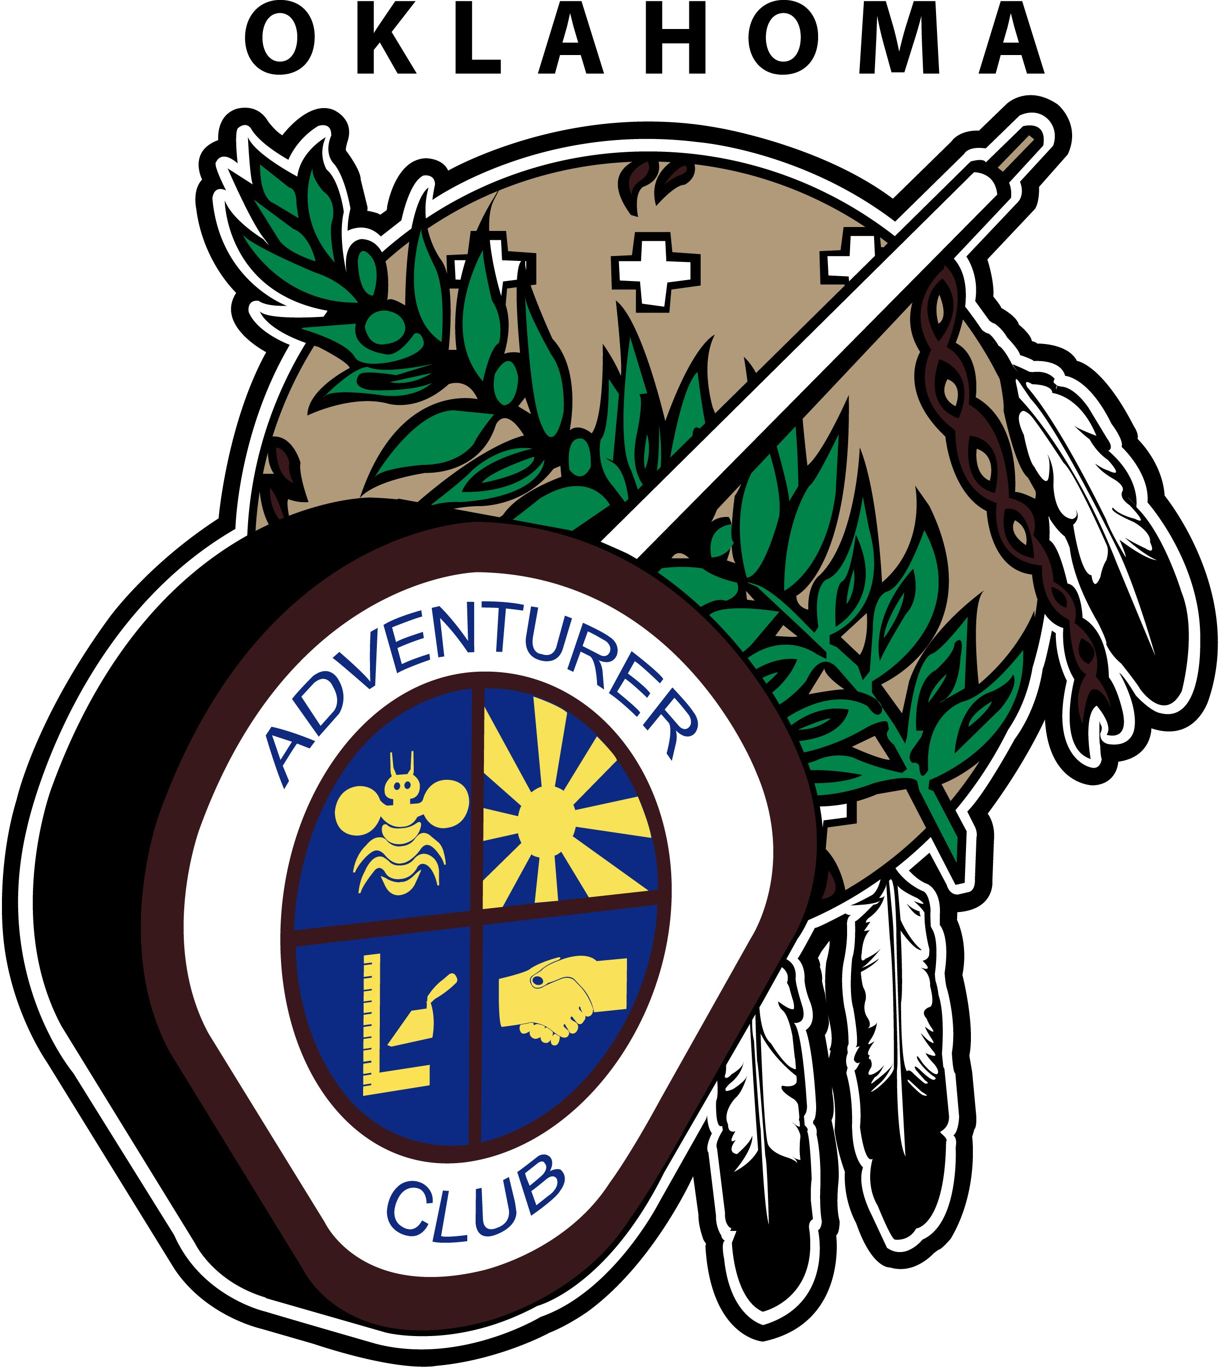
Adventurers
Area 1: Claudia Andujo
Bartlesville, Nowata, Vinita, Miami, Ketchum, Jay, Owasso, Collinsville, Pryor, Wagner, Tahlequah, Stilwell, Tulsa area churches

Steve Szalay, Area 2:
Ponca City, Cleveland, Stillwater, Perkins, Sand Springs, Chandler, Bristow, Sapulpa, Seminole, Okmulgee, Muskogee, Stigler, Sallisaw, West Siloam Springs.

Annette Park, Area 3:
Guthrie, Norman, Greater Oklahoma City area churches.

Donna Hill, Area 4:
Altus, Lawton, Chickasha, Duncan, Pauls Valley, Ada, Davis, Sulphur Shawnee, Ardmore, Coalgate, Durant, McAlester, Wilburton, Tuskahoma, Antlers, Hugo, Idabel, Waurika Lake, Wewoka Woods.

Norma Shepherd, Area 5:

